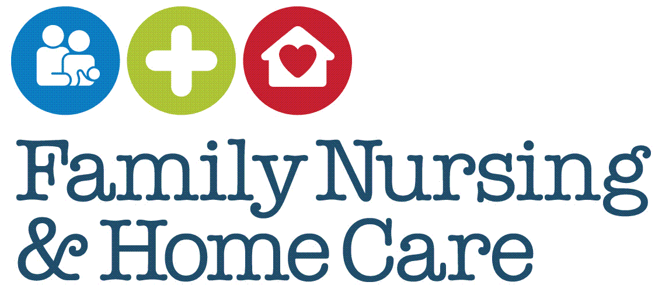

**Clinical Governance Framework**

**Date Approved**

**January 2025**

**Document Profile**

|  |  |  |
| --- | --- | --- |
| **Type** | Framework | |
| **Title** | Clinical Governance Framework | |
| **Author** | Claire White | |
| **Category** | | Clinical Governance |
| **Date approved by Organisational Governance Approval Group** | | 15/01/2025 |
| **Date approved by Chief Executive Officer** | | N/A |
| **Review date** | 3 years from approval | |
| **Document Status** | This is a controlled document. Whilst this document may be printed, the electronic version posted on the intranet is the controlled copy. Any printed copies of this document are not controlled. As a controlled document, this document should not be saved onto local or network drives but should always be accessed from the intranet. | |

**Version Control/Changes Made**

|  |  |  |  |
| --- | --- | --- | --- |
| **Date** | **Version** | **Summary of changes** | **Author** |
| June 2021 | 1 | New framework introduced | Claire White |
| Jan 2025 | 2 | Strategic priorities updated  Roles/Titles updated  References to publications updated (policies and procedures) | Claire White |

**CONTENTS**

1 INTRODUCTION 1

1.1 Rationale 1

1.2 Scope 2

1.3 Role and Responsibilities 2

2 FRAMEWORK 2

2.1 Education, Training, Continuous Professional Development (CPD) 3

2.1.1 Related FNHC Documents 3

2.2 Clinical Effectiveness 4

2.2.1 Related FNHC Documents 4

2.3 Safety 4

2.3.1 Related FNHC Documents 4

2.4 Risk Management 5

2.4.1 Related FNHC Documents 5

2.5 Information Management 5

2.5.1 Related FNHC Documents 5

2.6 Leadership & Staff 6

2.6.1 Related FNHC Documents 6

2.7 Involvement and Experience 6

2.7.1 Related FNHC Documents 6

3 MONITORING COMPLIANCE 6

4 CONSULTATION PROCESS 7

5 EQUALITY IMPACT STATEMENT 7

5.1 EQUALITY IMPACT SCREENING TOOL 9

6 IMPLEMENTATION PLAN 10

7 REFERENCES 10

# INTRODUCTION

## Rationale

Family Nursing & Home Care (FNHC) is committed to providing safe, high-quality care and services which are supported by systems and processes which promote continuous improvement, learning and assurance.

Figure1. FNHC Mission, Vision Values and Strategic Priorities

Clinical Governance is the system through which organisations are accountable for continuously improving the quality of their services and safeguarding high standards of care by creating an environment in which excellence in clinical care will flourish.

(Scally and Donaldson, 1998).

The Jersey Care Commission Home Care Standards (2019) require that:

***“9.1 There will be a coherent and integrated organisational and governance framework in respect of home care services.***

*This will be appropriate to the needs, size and complexity of the service.*

*There will be clear lines of professional and corporate accountability which assure the effective delivery of the service.”*

This framework outlines what systems and processes FNHC has in place to demonstrate accountability for continuous improvement and high standards of care.

## Scope

This framework applies to all FNHC employees and Committee members and relates to clinical governance.

## Role and Responsibilities

**Main Committee**

The main committee hold overall accountability for activities carried out at FNHC and for ensuring that FNHC has systems in place and resources available in order to carry out continuous monitoring, learning and quality improvement to support high standards of safe effective care.

**Governance Sub-Committee**

The Governance Sub-Committee are responsible for reviewing quarterly, quality and performance reports and reporting the outcomes to the main committee, identifying any areas where further review is required.

**Director of Governance and Care**

The Director of Governance and Care is responsible for producing quarterly, quality and performance reports for the Governance Sub-Committee and actioning further review where required.

**Governance Team**

The Governance Team will carry out, develop and support the delivery of systems and processes outlined within the framework.

**All employees/volunteers**

Employees/volunteers are expected to participate in governance activities, systems and processes as per individual policy and procedural requirements.

# FRAMEWORK

Figure 2 (overleaf) highlights each element of clinical governance at FNHC, organisational expectations for each element are outlined below.

Figure 2.

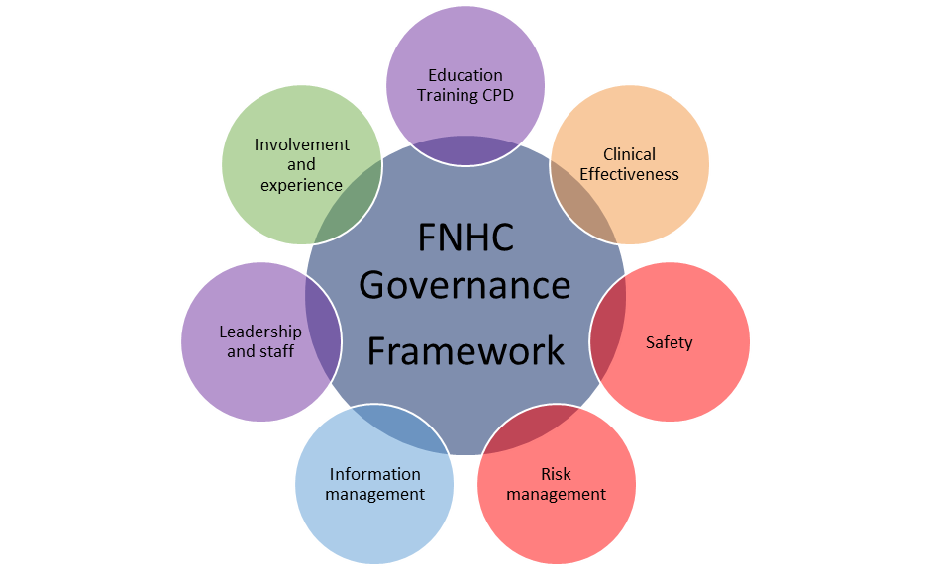

## Education, Training, Continuous Professional Development (CPD)

* New staff will complete a structured induction programme which will assess their competence to work without direct supervision.
* Staff will complete and remain up to date with statutory and mandatory training requirements.
* Staff will be appropriately qualified and supported to maintain and develop their competence through CPD.

### Related FNHC Documents

Induction Policy

Mandatory Training Policy

Non-Mandatory Education, Training and Development Policy

## Clinical Effectiveness

* Policies and procedures will be up to date and based upon the best available evidence and research.
* Clinical audit will be carried out to measure quality, compliance and establish areas for improvement/learning.
* Where learning is identified, evidence and research will be appraised and implemented to support improvement.
* There will be systems and processes across the organisation for Quality Assurance.

### Related FNHC Documents

Publications Policy

Annual Audit Programme

Standard Operating Procedures

Audit Process Standard Operating Procedures

## Safety

* Staff will receive training to recognise and respond appropriately to signs of abuse/neglect.
* Safeguarding policies and procedures will be up to date, based upon best practice and in line with requirements of the Jersey Safeguarding Partnership Board.
* Staff will understand fire and other emergency procedures.
* Accidents, incidents and near misses will be reported and investigated so that learning can be identified to help prevent recurrence.
* Health and Safety policies will be up to date and based upon legislative requirements, codes of practice and evidence.
* Risk assessments will be undertaken appropriately to support the avoidance of harm.
* There will be a system for cascading alerts and patient safety notices.

### Related FNHC Documents

Safeguarding Policy for Adults and Children

Domestic Abuse Practice Guidance

Multi-Agency Pre-Birth Protocol for Unborn Babies

Safeguarding Partnership Board Professional Differences/Escalation Policy

Safeguarding Restorative Supervision Policy

Health and Safety Policy

Incident Reporting Procedures

Learning Events Investigation Procedures

Safety Alerts Procedure

## Risk Management

* Risk management policies will be up to date and based upon best practice and evidence.
* Risks to service provision will be identified and escalated appropriately as detailed within Risk Management Procedures.
* Each service will monitor and regularly update its risk register.
* Appropriate control measures will be taken to help mitigate risk where possible.

### Related FNHC Documents

Risk Management Policy

Escalation Policy

Business Continuity Plan

## Information Management

* Information about services will be available in various formats.
* There will be policies and procedures for the safe and effective management of records.
* Staff will comply with Data Protection and confidentiality requirements, understanding requirements in respect of safeguarding and public interest.
* There will be effective data sharing agreements in place to support appropriate information sharing.

### Related FNHC Documents

Information Governance Policy

Information Governance Framework

Staff Work Diary Procedure

## Leadership & Staff

* Staff will be safely recruited.
* There will be up to date human resources policies and procedure based upon best practice and evidence.
* There will be sufficient, competent, appropriately trained staff to deliver services.
* There will be a leadership development pathway which details competencies and skills expected of managers and leaders.
* There will be a learning and just organisational culture.

### Related FNHC Documents

Safer Recruitment Policy

Employee Handbook

Learning Events Investigation Procedures

Skills and Competency Framework

## Involvement and Experience

* Any person using or affected by services will be encouraged to provide feedback, comment, complain or compliment with ease to inform learning and improvement.
* There will be up to date policies and procedures for complaints and feedback based upon best practice and evidence.
* There will be a strategy to support involvement and coproduction using experience to guide quality and safety improvement.

### Related FNHC Documents

Policy for the Management of Complaints

Friends and Family Test

Programme Surveys

Staff Survey

# MONITORING COMPLIANCE

This framework will be updated regularly in line with requirements from the Jersey Care Commission and best practice and evidence.

# CONSULTATION PROCESS

|  |  |  |
| --- | --- | --- |
| **Name** | **Title** | **Date** |
| Elspeth Snowie | Head of Quality & Safety | 06/12/24 |
| Tia Hall | Operational Lead (Adult Services) | 06/12/24 |
| Michelle Cumming | Operational Lead (Child & Family Services) | 06/12/24 |
| Stuart Waddingham | Deputy Operational Lead (Adult Services) | 06/12/24 |
| Rachel Foster | Quality & Performance Development Nurse | 06/12/24 |
| Teri O’Connor | Registered Manager Home Care | 06/12/24 |
| Justine Le Bon Bell | Head of Learning & Development | 06/12/24 |
| Claire Whelan | Head of Information Governance & Systems | 06/12/24 |
| Amanda De Freitas | Head of Human Resources | 06/12/24 |

# EQUALITY IMPACT STATEMENT

Family Nursing & Home Care is committed to ensuring that, as far as is reasonably practicable, the way services are provided to the public and the way staff are treated reflects their individual needs and does not discriminate against individuals or groups on any grounds.

This policy document forms part of a commitment to create a positive culture of respect for all individuals including staff, patients, their families and carers as well as community partners. The intention is to identify, remove or minimise discriminatory practice in the areas of race, disability, gender, sexual orientation, age and ‘religion, belief, faith and spirituality’ as well as to promote positive practice and value the diversity of all individuals and communities.

The Family Nursing & Home Care values underpin everything done in the name of the organisation. They are manifest in the behaviours employees display. The organisation is committed to promoting a culture founded on these values.

**Always:**

* Putting patients first
* Keeping people safe
* Have courage and commitment to do the right thing
* Be accountable, take responsibility and own your actions
* Listen actively
* Check for understanding when you communicate
* Be respectful and treat people with dignity
* Work as a team

This policy should be read and implemented with the Organisational Values in mind at all times. See overleaf/below for the Equality Impact Assessment for this policy.

## EQUALITY IMPACT SCREENING TOOL

|  |  |  |  |  |  |  |  |  |  |  |
| --- | --- | --- | --- | --- | --- | --- | --- | --- | --- | --- |
| **Stage 1 - Screening** | | | | | | | | | | |
| Title of Procedural Document: Clinical Governance Framework | | | | | | | | | | |
| Date of Assessment | | 09/12/24 | | Responsible Department | | | | | Governance | |
| Completed by | Claire White | | | Job Title | | | Director of Governance & Care | | | |
| **Does the policy/function affect one group less or more favourably than another on the basis of**: | | | | | | | | | | |
|  | | | | | | **Yes/No** | | **Comments** | | |
| Age | | | | | | No | |  | | |
| Disability  *(Learning disability; physical disability; sensory impairment and/or mental health problems e.g. dementia)* | | | | | | No | |  | | |
| Ethnic Origin *(including hard to reach groups)* | | | | | | No | |  | | |
| Gender reassignment | | | | | | No | |  | | |
| Pregnancy or Maternity | | | | | | No | |  | | |
| Race | | | | | | No | |  | | |
| Sex | | | | | | No | |  | | |
| Religion and Belief | | | | | | No | |  | | |
| Sexual Orientation | | | | | | No | |  | | |
| **If the answer to all of the above questions is NO, the Equality Impact Assessment is complete. If YES, a full impact assessment is required: go on to stage 2.** | | | | | | | | | | |
| **Stage 2 – Full Impact Assessment** | | | | | | | | | | |
| **What is the impact** | | | **Level of Impact** | | **Mitigating Actions**  **(what needs to be done to minimise / remove the impact)** | | | | | **Responsible Officer** |
|  | | |  | |  | | | | |  |
| **Monitoring of Actions** | | | | | | | | | | |
| The monitoring of actions to mitigate any impact will be undertaken at the appropriate level | | | | | | | | | | |

# IMPLEMENTATION PLAN

|  |  |  |
| --- | --- | --- |
| **Action** | **Responsible Person** | **Planned timeline** |
| Policy to be uploaded to the Procedural Document Library | Education and Development Administrator | Within 2 weeks following ratification |
| Email to all staff | Education and Development Administrator | Within 2 weeks following ratification |

# REFERENCES

Scally G, Donaldson LJ, (1998) Clinical Governance and the drive for quality improvement in the new NHS in England, BMJ, 1998;317:61-6