

**Standard Operating Procedures**

**Lower Limb Treatment and Management Pathway**

Date Approved

January 2025

**Document Profile**

|  |  |
| --- | --- |
| **Type** | Standard Operating Procedures |
| **Title** | Lower Limb Treatment and Management Pathway |
| **Author(s)** | TVN Gilly Glendewar, TVN Stephanie Hall, TVN Caroline Zinyemba |
| **Category** | Clinical |
| **Version** | 1.0 |
| **Approval Route** | Organisational Governance Approval Group (OGAG) |
| **Date approved** | 15/01/2025 |
| **Review date** | 1 year from approval |
| **Document Status** | This is a controlled document. Whilst it may be printed, the electronic version posted on the intranet is the controlled copy. Any printed copies of this document are not controlled. As a controlled document, it should not be saved onto local or network drives but should always be accessed from the intranet. |

**Version Control**

|  |  |  |
| --- | --- | --- |
| **Date** | **Version** | **Summary of changes made** |
|  |  |  |
|  |  |  |
|  |  |  |

**Contents**

Introduction 4

SOP 1 Patient Assessment 5

SOP 2 Doppler 6

SOP 3 Pictures and Measurements 9

SOP 4 Garment Choice and Ordering 11

SOP 5 Recalling Patient for Fitting and Ongoing Care 13

References 14

Appendices 15

Appendix 1. GP Process for Requesting FNHC Doppler Test 15

Appendix 2. Compression Hosiery & Wrap Measurements and Product Selection Form 16

Glossary 18

# Introduction

The purpose of this Standard Operating Procedure is to establish expected practice standards for Lower Limb assessment and management for community patients.

This Standard Operating Procedure will remove unwanted variation in clinical practice and by following best practice guidelines aims to reduce inappropriate care or delays to treatment, thus improving health outcomes, reducing preventable harm and decreasing wastage.

This Standard Operating Procedure on Lower Limb assessment and management provides information for clinicians that care for a person with a lower limb problem, in community settings, where patients require treatment, monitoring, and education in relation to their leg problem.

Lower limb assessment and management is a fundamental area of community nursing practice that all registered nurses, should have the competence to undertake. It should be recognised that with clear training and support and agreed competencies Senior Healthcare Assistants (SHCAs) have a role in the provision of this care also.

The SOPs within this document detail the full pathway for Lower Limb assessment and management, including:

* holistic patient assessment on admission
* specific lower limb assessment
* Doppler
* deciding treatment pathways
* the taking of photographs
* wound assessment
* wound measuring
* measuring for compression garments
* choosing compression garments or bandaging
* how to order the correct garments
* how to discharge the patient when healed

how to recall patient for review, additional hosiery, the fitting of hosiery and ongoing patient care and support.

# SOP 1 Patient Assessment

|  |
| --- |
| ***Purpose*** |

The completion of the Holistic assessment is the starting point of a care episode and is an important process that allows clinicians to identify and monitor the presence of any potential complications and to measure the effectiveness of treatment. This will be followed by specific lower limb assessments to determine the exact problem(s) being experienced and develop a plan of care that is relevant to that individual.

|  |
| --- |
| ***Scope*** |

All registered nurses following specific training and competency sign off. Managing individuals referred to FNHC with lower limb problems, additionally there is scope for Senior Healthcare Assistants within the teams to undertake aspects of these assessment following specific training and competency sign off.

|  |
| --- |
| ***Core Requirements/Procedure*** |

Perform holistic assessment of patient

Lower limb assessment

Wound assessment if required

Measurements and photographs using EMIS templates on admission to caseload and ongoing to track progress or deterioration

Doppler test to be scheduled within 2 weeks of admission to caseload to determine if severe arterial compromise and if compression is suitable

Discuss diagnosis and treatment plan with patient, identify their goals and wishes

Provide appropriate education and information regarding potential life-long compression, healing, weight, nutrition, smoking, exercise, elevation and skin care.

Dress if wound is present, choose the most appropriate dressing to manage the needs of wound e.g. exudate control, debriding of slough, treat infection

If suitable for compression, consider what type of compression is required to manage the condition: bandages, wraps or stockings (flat knit or circular knit, open toe or closed toes)

Determine if the patient wishes to have compression therapy, if yes, can they apply and remove the garments independently, do they need carer support or an applicator aid.

# SOP 2 Doppler

|  |
| --- |
| ***Purpose*** |

Hand-held Doppler examination is used to determine whether the patient has underlying arterial disease, which may influence the treatment pathway chosen for the patient.

|  |
| --- |
| ***Scope*** |

This will be performed by Registered Nurses and SHCAs who have had the relevant training and competency signed off.

They will record the information on the Doppler EMIS template

The registered nurse will interpret the results and determine if the patient is suitable for compression.

The SHCA will report to the registered nurse any test results they have undertaken, asking the registered nurse to interpret the results.

|  |
| --- |
| ***Core Requirements/Procedure*** |

Explain the procedure, reassure the patient, and ensure that they are lying flat on their back and are comfortable, relaxed and rested with no pressure on the proximal vessels. If they are unable to lie flat, record the position they can lie in the EMIS records on the Doppler template.

**1. Measure the brachial systolic blood pressure**

* Place an appropriately sized cuff around the upper arm
* Locate the brachial pulse and apply ultrasound contact gel
* Angle the Doppler probe at 45 degrees and move the probe to obtain the best signal
* Inflate the cuff until the signal is abolished then deflate the cuff slowly and record the pressure at which the signal returns being careful not to move the probe from the line of the artery
* Repeat the procedure for the other arm, record both readings on EMIS
* Use the higher of the two values to calculate the ABPI

**2. Measure the ankle systolic pressure**

* Place an appropriately sized cuff around the ankle immediately above the malleoli having first protected any ulcer that may be present using the cling film provided.
* Examine the foot, locating the dorsalis pedis or anterior tibial pulse, you can mark with skin marker pencil if desired, and apply ultrasound contact gel
* Continue as for the brachial pressure, recording this pressure in the same way
* Repeat this for the posterior tibial and the peroneal arteries
* Dorsalis pedis – top of foot from base of great toe towards lower leg
* Anterior tibial – follow line of artery for the Dorsalis pedis
* Posterior Tibial – which is located posterior to the medial malleolus
* Peroneal – which is located posterior to the lateral malleolus

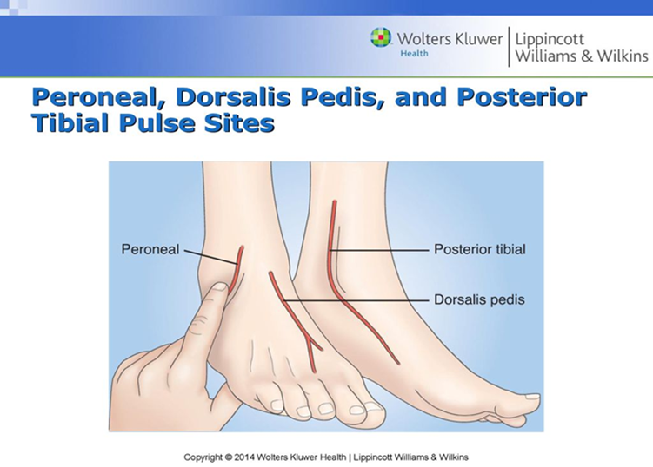

Use the highest reading obtained to calculate the ABPI for that leg

Repeat for the other leg

Calculate the ABPI for each leg

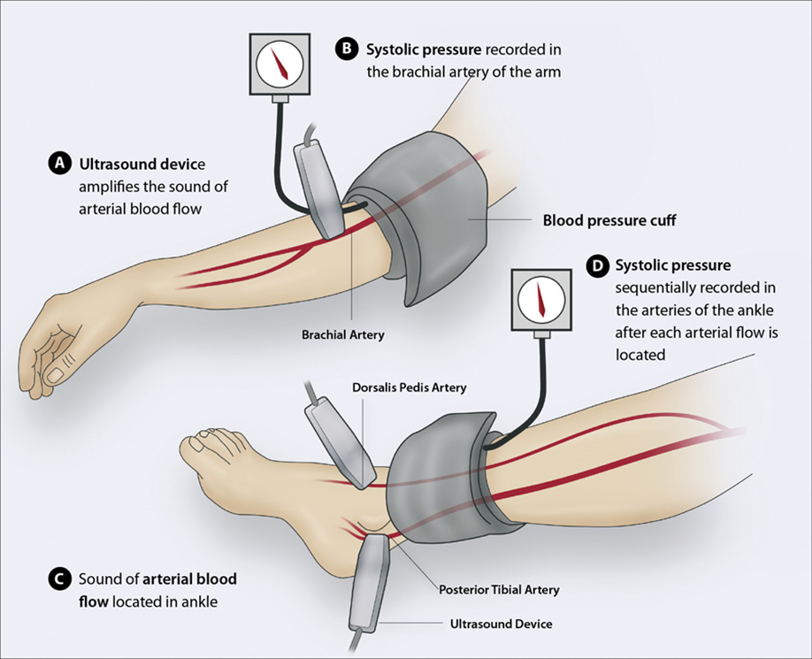

<https://wounds-uk.com/wp-content/uploads/2024/09/MESI24_BPS_ABPI_WUK-web-v2.pdf>

<https://wounds-uk.com/wp-content/uploads/2023/02/d9d4688943fa8146f1579be583bbb608.pdf>

<https://wounds-uk.com/wp-content/uploads/2023/02/content_11510.pdf>

When calculating the ABPI using the Doppler method, meticulous attention to detail is necessary to obtain valid measurements; a lack of awareness of the limitations of the ABPI leads to conflicting results and misinterpretation of data. When the procedure is followed correctly with proper consideration of the factors involved it indicates that this is a safe and reliable method of monitoring arterial disease.

FNHC have an automated Mesi Doppler in our clinic settings (New Era & St Peter). This equipment, whilst quicker to perform a Doppler is not as accurate and needs a normal limb shape for best results. They can be used when performing a follow up Doppler when baseline is already known, or when normal limb shape. However, the first line choice when performing a Doppler is the Hand-held machine.

Additionally, FNHC has a Toe doppler, this is held by the Tissue Viability team who will undertake the toe doppler assessment in conjunction with a member of the community nursing team. It is especially accurate for those patients with known vascular issues and diabetes.

<https://www.huntleigh-diagnostics.com/products/dopplex-atp-kit/>

When a GP requests a Doppler, they need to send a full referral with reason for Doppler, medical indications, history and what they hope to achieve. We should decline referrals where this is not included and return it to the GP asking for the relevant information to be forwarded to FNHC before we contact the patient. (appendix 1)

# SOP 3 Pictures and Measurements

|  |
| --- |
| ***Purpose*** |

Digital photography and measurements of wound size, anatomical position of wounds, and leg size provides visual confirmation and context for written records and helps provide a timeline for healing status. Images and measurements are valuable for various reasons including assisting compression selection and dressing choices.

|  |
| --- |
| ***Scope*** |

All registered nurses and SHCAs undertaking wound care and lower limb management and treatments and assessments.

|  |
| --- |
| ***Core Requirements/Procedure*** |

Ask patient for consent to take photos, follow FNHC SOP for photography

Use a work device, upload to EMIS and then delete from device

Linear Wound Measurement is the most common, and is also known as the clock method, you measure the greatest length, greatest width, and greatest depth of the wound while referencing the face of an imaginary clock. When using the clock method, you would document the longest length of the wound by imagining the face of the clock over the wound bed, and then measure the greatest width. On the feet, the heels are always at 12 o’clock and the toes are always at 6 o’clock. Document all measurements in centimetres, as L x W x D. It’s also important to remember that sometimes the length will be smaller than the width.

**When measuring length, keep in mind that:**

* The head is always at 12 o’clock.
* The feet are always at 6 o’clock.
* Your ruler should be placed over the wound on the longest length using the clock face.

**When measuring width:**

* Measure perpendicular to the length, using the widest width.
* Place your ruler over the widest aspect of the wound and measure from 3 o’clock to 9 o’clock.

**When measuring depth:**

* Place a probe into the deepest part of the wound bed.
* Where the probe meets the wound margin and place it against the ruler.
* All wounds must have a depth recorded.
* For wounds without depth (Stage I and DTIs), record depth as “0 cm.”

For wounds that are open but appear to have no depth, record depth as “<0.1cm”

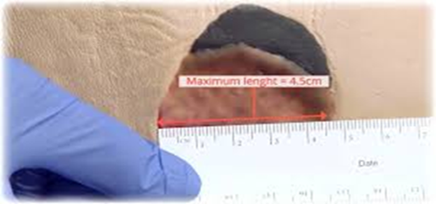

Use a disposable tape or one that can be cleaned with Clinell wipes or equivalent.

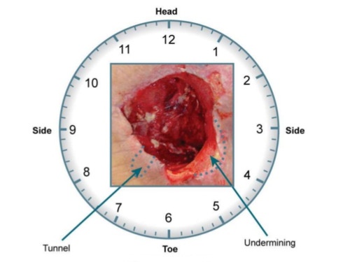

Use the clock face method to record the measurements

When measuring any tunnelling and/or undermining

# SOP 4 Garment Choice and Ordering

|  |
| --- |
| ***Purpose*** |

To support all registered nurses and SHCAs in the determining the correct compression for a specific patient to manage and treat their lower limb condition or wound.

|  |
| --- |
| ***Scope*** |

All FNHC staff who manage patients with these conditions.

Those staff who have had relevant training and competencies signed off.

The Tissue viability team check the request prior to processing for dispensing and can be a useful resource if the nurse/SHCA is unsure as to what to request. The individual needs to contact the TV team to arrange to discuss the request and establish the correct product and size for their patient.

|  |
| --- |
| ***Core Requirements/Procedure*** |

The patient will have been fully assessed and deemed that the application of compression stockings and wraps is the appropriate treatment plan.

**Team Process for Hosiery & Wrap Requests:**

The teams are responsible for assessing and deciding the type and size of compression a patient requires. If any member of the team is unsure, they need to contact the TV team and arrange to meet with them to work through the selection and sizing process for that patient.

The type of compression is dependent on the limb shape, level of oedema, skin fragility as well as the ability of patient to apply and if they have support/carers to apply if needed.

**Process:**

1. Lower limb assessment
2. Photographs of both legs to show front, back and sides
3. Doppler to have been completed – if not possible record why
4. Determine cause: venous, arterial or mixed insufficiency
5. Check eligibility criteria for compression – venous or mixed insufficiency
6. Patient wishes to go into compression
7. Show patient samples of hosiery and wraps
8. Complete measurement form that is on EMIS in documents
9. Check size and fit of compression and ability to apply using samples and applicator aids and use disposable plastic leg cover to prevent contamination of samples
10. Send fully completed measurement form to: [compression@fnhc.org.je](mailto:compression@fnhc.org.je)
11. Confirmation will be sent of receipt and processing will commence
12. Order delivered to team or clinic
13. Fit with patient: check ability to get on and off correctly
14. Photograph compression on patient and load to EMIS
15. If nurse unhappy with fit do not leave compression with the patient: return with patient details, reason for return and what is required

**TV team & Stores role:**

The type of compression is dependent on the limb shape, level of oedema, skin fragility as well as the ability of patient to apply and if they have support/carers to apply if needed.

**TV Team Compression file:**

1. Email received from team requesting hosiery
2. Check measuring form completed and product/size documented, if not then contact nurse sending it and arrange to meet to work out correct product and size required.
3. If form complete, quickly check choices/size then send to Stores on Hosiery Request Form where it will be dispensed and taken to team or clinics
4. Record on EMIS hosiery order received, outcome and complete hosiery request form for patient notes.
5. Save electronic copy of hosiery request form in TVN compression folder and print copy for compression folder to aid follow ups
6. Weekly check with Stores to update Hosiery Request Form as dispensed or still pending
7. Made To Measure forms to be emailed to Essity: [Compression.uk@jobst.com](mailto:Compression.uk@jobst.com) save a printed copy in file
8. Edit MTM form and update when received
9. Save emails in relevant folders on shared compression email to enable checks are possible
10. regularly review “follow up needed” folder in compression email to review any outstanding orders and offer team support where needed

# SOP 5 Recalling Patient for Fitting and Ongoing Care

|  |
| --- |
| ***Purpose*** |

To ensure the stockings ordered are a correct fit, to show and educate the patient on when and how to apply/remove and care for their garments.

|  |
| --- |
| ***Scope*** |

Registered nurses and SHCAs who undertake the assessments for people with lower limb conditions that require compression garments.

Patients and carers who require ongoing compression garments and who will move on to self-care.

|  |
| --- |
| ***Core Requirements/Procedure*** |

Make sure the patient/family/carer is deemed confident in applying compression garment properly

Educate on the use of applicators and assess ability of self-care or the need for carer support

Show patient/family/carer how to apply one leg, use single patient use limb protector so as not to contaminate stocking/wrap, and let the patient/family/carer apply the other leg under supervision teaching the correct technique

Once the fitting is established to take a picture of the stocking on limb, whole leg(s) to show well fitting.

Check the patient is happy with the product, colour and with/without toes is correct

Give hosiery patient information leaflet *(pending)*

If no other nursing needs to follow up patient in 12 weeks routine quick check of measurements if patient requires another set of stockings

Thereafter will be 6 monthly or annual recall for Doppler check and reassessment depending on wear or changes in condition, or recurrence of leg ulceration, remeasure limb (hosiery measuring form as above) and check which size and product are needed, this may be different from the original decisions made. This should be added to the EMIS scheduling system for each team.

# References

National Wound Care Strategy Programme (NWCSP) (2024) Lower Limb Recommendations. Available at: [NWCSP-Leg-Ulcer-Recommendations-final-version-15.07.2024.pdf](https://www.nationalwoundcarestrategy.net/wp-content/uploads/2024/07/NWCSP-Leg-Ulcer-Recommendations-final-version-15.07.2024.pdf) Accessed on: 10.10.24

National Wound Care Strategy Programme. Digital Images in Wound Care. Available at: https://www.nationalwoundcarestrategy.net/wpcontent/uploads/2021/09/Digital-Images-in-wound-care-17Sept24.pdf Accessed on: 10.10.24

NICE. Diagnostics guidance (DG52) Automated ankle brachial pressure index measurement devices to detect peripheral arterial disease in people with leg ulcers. Available at: <https://www.nice.org.uk/guidance/dg52>. Accessed on: 10.10.24

Wounds UK. Best Practice Statement: Holistic management of venous leg ulceration (second edition). Available at: https://wounds-uk.com/wpcontent/uploads/sites/2/2023/02/d9d4688943fa8146f1579be583bbb608.pdf. Accessed on: 10.10.24

Wounds UK (2023) Best Practice Statement: The use of compression therapy for peripheral oedema: considerations in people with heart failure. Wounds UK

Moffatt C, Martin R, Smithdale R (2007) Leg Ulcer Management. Blackwell Publishing, Oxford Royal College of Nursing (2006) Clinical Practice Guidelines: The nursing management of patients with venous leg ulcers.

RCN, London Scottish Intercollegiate Guidelines Network (2010) Management of chronic venous leg ulcers: A national clinical guideline. SIGN

# Appendices

# Appendix 1. GP Process for Requesting FNHC Doppler Test

# Appendix 2. Compression Hosiery & Wrap Measurements and Product Selection Form

Double-click on the icon to open the form

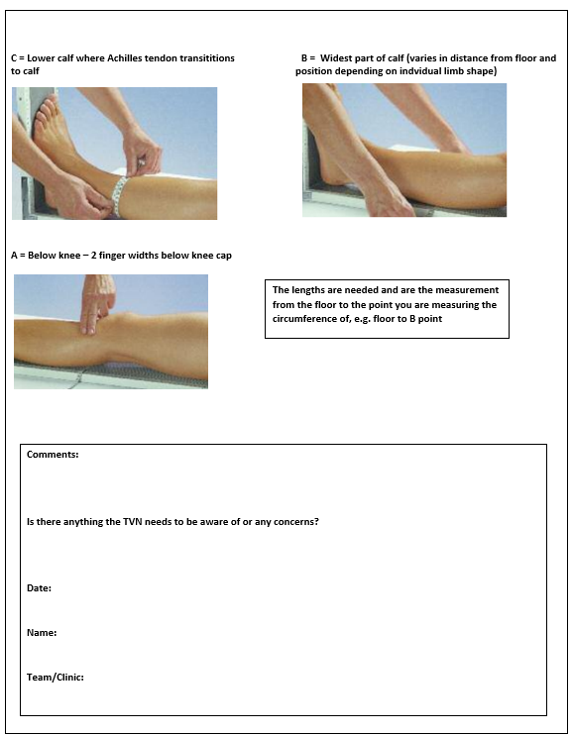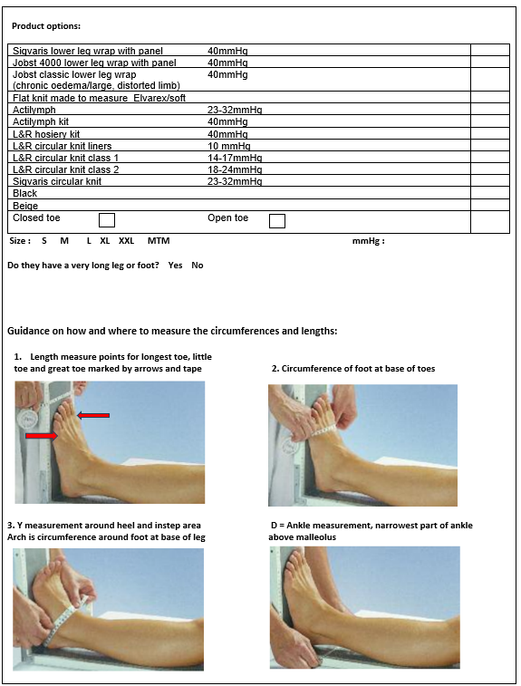

# Glossary

**ABPI: Ankle Brachial pressure index (ABPI)** is a reading obtained following the use of a non-invasive method to assess peripheral arterial perfusion on the lower limb. Using a manual doppler ultrasound device, the ABPI is calculated by dividing the systolic blood pressure of the ankle with the brachial artery in the arm.

**Acute Limb Ischaemia:** Rapid decrease in blood flow to lower limb due to acute occlusion. Symptoms are sudden-onset, acute pain, pallor, pulseless, perishingly cold paraesthesia / acute sensory change, paralysis/ acute motor dysfunction.

**ANTT: Aseptic non-touch technique.** This is the practice of avoiding contamination by not touching key elements of the wound or the dressing, e.g., the inside surface of a sterile dressing where it will be in contact with a wound.

**Chronic Kidney Disease:** is defined as a reduction in kidney function or structural damage (or both) present for more than 3 months, with associated health implications.

**Chronic Limb Threatening Ischaemia (CLTI):** is a clinical syndrome defined by the presence of peripheral arterial disease (PAD) in combination with rest pain, gangrene or a lower limb ulceration greater than 2 weeks in duration.

**Chronic oedema:** Is defined as swelling that lasts for more than 3 months.

**Erythema:** Inflammation of the skin, often referred to as ‘redness’ although it may present differently in a range of skin tones.

**Healed:** Is defined as complete epithelisation.

**Hyperkeratosis:** Thickening/ scaling of the outer layer of the skin, common around a leg ulcer.

**Leg Ulcer:** An ulcer that originates on or above the malleolus but below the knee that takes more than 2 weeks to heal.

**Lymphoedema:** is defined as a gradual abnormal build-up of lymph fluid in the tissues resulting from a failure of the lymphatic system. Consequences are swelling, skin and tissue changes and predisposition to infection.

**Mild Graduated Compression:** Compression therapy that is intended to apply 20mmHg or less at the ankle. This is about half of the therapeutic dose of strong compression therapy.

**Peripheral Arterial Disease (PAD):** is a common condition where a build-up of fatty deposits in the arteries restricts blood supply to the limbs.

**Strong Graduated Compression:** is either an elastic compression system applied to give at least 40mmHg of pressure at the ankle or an inelastic system applied in accordance with manufacturers’ recommendations. Strong compression delivers what current evidence suggests is the full therapeutic dose for treating venous leg ulcers.

**Toe Pressure:** **Resting systolic Toe Pressure (TP)** is a measure of small arterial function in the lower limb. TP is often used in adjunct to the ABPI when screening for peripheral arterial disease (PAD). This particularly in the presence of lower limb medial arterial calcification common in those with Diabetes and renal disease, providing a more accurate picture of blood flow.

**Venous insufficiency:** a form of venous disease where problems with the venous system affects the return of blood from the lower limb to the heart. Venous insufficiency is commonly due to failure within the valves in the veins and can affect the deep or superficial venous systems.

**Venous leg ulcer:** Ulcers on the leg(s) that are caused by venous insufficiency.