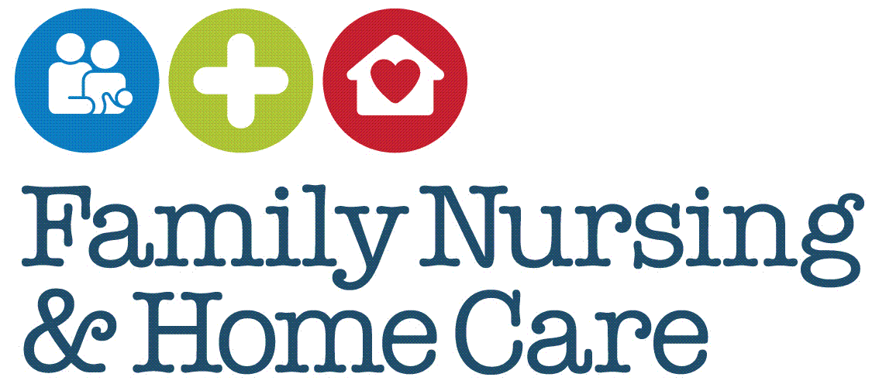

**Standard Operating Procedures**

**Implementation of the Rockwood Clinical Frailty Scale (CFS)**

February 2025

**Document Profile**

|  |  |
| --- | --- |
| **Type** | Standard Operating Procedures |
| **Title** | Implementation of the Rockwood Clinical Frailty Scale (CFS) |
| **Author(s)** | Paul Gartshore, Hannah Lowe, Tania Heaven |
| **Category** | Clinical |
| **Version** | 1 |
| **Approval Route** | Organisational Governance Approval Group (OGAG) |
| **Date approved** | 5th February 2025 |
| **Review date** | 3 years from approval |
| **Document Status** | This is a controlled document. Whilst it may be printed, the electronic version posted on the intranet is the controlled copy. Any printed copies of this document are not controlled. As a controlled document, it should not be saved onto local or network drives but should always be accessed from the intranet. |

**Version Control**

|  |  |  |
| --- | --- | --- |
| **Date** | **Version** | **Summary of changes made** |
| February 2025 | 1 | New standard operating procedures |
|  |  |  |
|  |  |  |

**Contents**

Introduction 4

SOP 1: Patient Engagement 5

SOP 2: Conducting the Assessment 6

SOP 3: Scoring the Clinical Frailty Scale 7

SOP 4: Documentation 8

SOP 5: Follow-Up 9

References 10

Appendices 11

Appendix 1 Frailty 11

Appendix 2 Clinical Frailty Scale 14

Appendix 3 Top Tips 15

Appendix 4 Clinical Frailty Scale (CFS): Classification Tree 16

# Introduction

Frailty is a multifactorial syndrome associated with aging and chronic disease, marked by decreased resilience and higher vulnerability to health stressors. With appropriate training, it is possible to understand frailty and complete high-level assessments and management strategies to significantly improve health outcomes and quality of life for older adults.

The Rockwood **Clinical Frailty Scale (CFS)** is the tool of choice at Family Nursing & Home Care (FNHC) and is recommended by clinical guidelines such as National Institute for Health and Care Excellence (NICE) CG161 and the World Guidelines for Prevention and Management of Falls in Older Adults. It is a widely used tool that classifies individuals from very fit (level 1) to terminally ill (level 9) based on clinical judgment and observed functional status. This SOP details its use for staff.

**Why do we need to use a formal Frailty assessment?**

Jersey has an aging population. The risk of frailty related complications like falls, hospitalisation, and reduced quality of life increases with age. Unfortunately, approximately half of people over 85 years old admitted to hospital die within a year. A significant percentage of our patient caseload within FNHC are over 65 years old. Implementing an assessment like the **Rockwood Clinical Frailty Scale (CFS)** provides a quick, reliable, and valid tool to enable the communication of Islanders needs effectively. Interventions can then be tailored and a measurement of the effectiveness of these interventions made. It also allows identification of vulnerable adults to help them live well and age well and in turn reduces the strain on all healthcare services and improves their overall outcomes.

***Frailty is reversible if tackled soon enough and proactively.***

**Training to implement a Frailty assessment**

Training is needed to ensure clear documentation, communication using the same language and outcomes. The training makes sure information is accurate and consistent, facilitating effective assessment. It then enables appropriate interventions and improved patient outcomes and the ability to measure these outcomes. This in turn can reduce adverse health events, improve functional ability, improving overall quality of life and independence in the community.

**Detailed information on Frailty**

Characteristics of frailty, causes and risk factors, diagnosis and assessment, implications of frailty, as well as management and interventions are discussed in more detail in Appendix 1

# SOP 1: Patient Engagement

***Purpose***

Securing patient engagement is necessary for the effective use of the Rockwood Clinical Frailty Scale (CFS).

***Scope***

This SOP applies to all healthcare professionals involved in the assessment and care of older adults in any healthcare setting using the Rockwood CFS and addresses the need for effective patient engagement.

***Core Requirements/Procedure***

Introduce the CFS assessment and explain to the patient (and their family if present) the purpose of the frailty assessment and how it will be conducted.

Obtain consent: Ensure informed consent is obtained from the patient. If the patient lacks capacity, follow local protocols for involving family members or legal representatives.

# SOP 2: Conducting the Assessment

***Purpose***

To provide healthcare professionals with a standardised method for assessing frailty in older adults using the Rockwood Clinical Frailty Scale (CFS)

***Scope***

This SOP applies to all healthcare professionals involved in the assessment and care of older adults in any healthcare setting and details how to conduct an assessment using the Rockwood CFS. ***N.B The CFS is only validated for patients over 65years old.***

***Core Requirements/Procedure***

**Equipment and Materials:**

* See SOP 1 Preparation
* Additional equipment such as mobility aids (if needed)

When assessing the patient, consider the following aspects below based on their usual state in past 2 weeks rather than how they present now, at this time, to ensure the assessment accurately reflects the patient’s baseline level of frailty:

* **Physical health**: Observe and enquire about the patient’s physical health, including their ability to perform activities of daily living (ADLs) such as bathing, dressing, and eating.
* **Cognitive Status**: Assess cognitive function through conversation, noting any signs of memory loss, confusion, or impaired judgment.
* **Social Factors**: Consider social support systems, living arrangements and any assistance the patient receives at home.

Dementia does not limit the use of the CFS. Refer to the CFS pictorial scale Appendix 2

# SOP 3: Scoring the Clinical Frailty Scale

|  |
| --- |
| ***Purpose*** |

To provide healthcare professionals with a standardised method for assessing frailty in older adults using the Rockwood Clinical Frailty Scale (CFS)

|  |
| --- |
| ***Scope*** |

This SOP applies to all healthcare professionals involved in the assessment and care of older adults in any healthcare setting and details how to use the Rockwood CFS scoring system.

|  |
| --- |
| ***Core Requirements/Procedure*** |

Refer to the CFS Chart (Appendix 2): The CFS ranges from 1 (very fit) to 9 (terminally ill). Match the patient’s overall status to the most appropriate level on the scale.

Level 1: Very Fit - Robust, active, energetic, well-motivated.

Level 2: Well - Without active disease but less fit than people in category 1.

Level 3: Managing Well - Medical problems well controlled but not regularly active.

Level 4: Vulnerable - Not dependent on others but symptoms limit activities.

Level 5: Mildly Frail - More evident slowing and need help with high-order Instrumental Activities of Daily Living (IADLs). e.g. managing technology, shopping, medications.

Level 6: Moderately Frail - Need help with all outside activities and with keeping house.

Level 7: Severely Frail - Completely dependent on personal care but stable.

Level 8: Very Severely Frail - Completely dependent, approaching the end of life. Could not recover from minor illness.

Level 9: Terminally Ill - Life expectancy less than 6 months, but not otherwise evidently frail.

# SOP 4: Documentation

***Purpose***

Best practice in recordkeeping will enable more effective use of the Rockwood Clinical Frailty Scale (CFS)

***Scope***

This SOP applies to all healthcare professionals involved in the assessment and care of older adults in any healthcare setting and will enable effective communication of the findings of the assessment. In addition to recordkeeping, it also includes care planning and communication with others.

***Core Requirements/Procedure***

Record findings by documenting the CFS score in the patient’s EMIS healthcare record along with any pertinent observations or notes from the assessment.

The CFS is a coded record and should be documented as such in a “Consultation” rather than free text.

Document in “Falls Risk Reduction Care Plan.” Use the CFS score to guide the development of a tailored care plan. This may include interventions such as physiotherapy and Social Work services.

Communicate results by sharing the CFS score and its implications with the patient, their family, and the multidisciplinary team involved in the patient’s care.

# SOP 5: Follow-Up

***Purpose***

To provide healthcare professionals with a standardised method for the follow up of interventions implemented after using the Rockwood Clinical Frailty Scale (CFS) to assess patient need.

***Scope***

This SOP applies to all healthcare professionals involved in the assessment and care of older adults in any healthcare setting and relates to the following up of interventions designed to support their safety and wellbeing.

***Core Requirements/Procedure***

Monitor and reassess the patient. Regularly review and update the patient’s frailty status and care plan, especially if there are changes in their health condition.

# References

Age UK [Online] Available at: https://www.ageuk.org.uk/our-impact/policy-research/frailty-in-older-people/understanding-frailty/ (Accessed 8/10/24).

Bieniek, J. (2016). Fried frailty phenotype assessment components as applied to geriatric inpatients. Clin Interv Aging. 11:453–45

British Geriatric Society [Online] Available at: https://www.bgs.org.uk/resources/introduction-to-frailty (Accessed 8/10/24).

National Institute for Health and Care Excellence (NICE) (2013) Falls in older people: assessing risk and prevention. [Online] Available at: https//www.nice.org.uk/guidance/cg161 (Accessed 8/10/24).

Rockwood, K. et al (2020) Clinical Frailty Scale. [Online] Available at: <https://www.dal.ca/sites/gmr/our-tools/clinical-frailty-scale.html> (Accessed 8/10/24).

World Guidelines for Falls prevention and management for older adults: a global initiative Montero, M et al (2022), Age and Ageing, Volume 52, Issue 10, October 2023.

# Appendices

# Appendix 1 Frailty

**Definition**

‘Frailty’ refers to a person’s mental and physical resilience, or their ability to bounce back and recover from events (or “stressors”) like illness and injury (Age UK). Although frailty is often associated with the elderly, it is NOT an inevitable part of aging. 10% of adults aged 65-69 are frail, but for those aged 85-90 this increases to 39% (British Geriatric Society, BGS). These statistics reflect the growing vulnerability to adverse health outcomes as Islanders age, emphasising the need for targeted interventions to support older adults.

Frailty is a clinical syndrome characterized by a reduced physiological reserve and increased vulnerability to these stressors e.g. falls or infections. It results from cumulative declines across multiple physiological systems, leading to decreased strength, reduced cognitive and functional ability.

Fortunately, frailty is reversible if we can tackle it soon enough and proactively.

**Detailed information on Frailty**

Frailty can be described in various ways for example, by **Frailty Syndromes** or **Frailty Phenotype**.

The following **FIVE Frailty Syndromes** are common clinical presentations that often indicate the presence of frailty in older adults:

1. Falls – unexplained and frequent falls
2. Delirium – acute confusion or cognitive changes
3. Incontinence – low of bladder and bowel control
4. Immobility- sudden and new inability or reduced mobility
5. Susceptibility to side effects of medication- increased sensitivity or adverse reaction to medications

These syndromes are often used to identify frailty as they represent common ways that frailty manifest in patients. This model of frailty is known as the Cumulative Deficit model described by Rockwood in Canada. It assumes an accumulation of deficits which can occur with ageing, and which combine to increase frailty which in turn will increase the risk of an adverse outcomes. Rockwood also proposed a **Clinical Frailty Scale (CFS)** for use after a comprehensive geriatric assessment of an older person.

Conversely, **Frailty Phenotype** describe the underlying physiological changes and symptoms associated with frailty. These five characteristics, as defined by the Fried Frailty Criteria are:

1. Weakness- with decreased muscle mass, and impaired balance and mobility.

2. Slower walking speed- and longer time to complete physical tasks.

3. Exhaustion –self reported feelings of fatigue or low energy.

4. Low physical activity levels – decreased amount of physical activity

5. Unintentional Weight Loss- over a short period, often indicating muscle loss and nutritional deficiencies.

Overall, this increased vulnerability leads to higher susceptibility to acute stressors, such as infections, surgery, or psychological stress, leading to health deterioration.

These methods of describing frailty help us build a picture of the patient which in turn helps us use the CFS.

**Causes and Risk Factors of Frailty:**

* Age-Related Changes: Natural decline in organ function and physical capability.
* Chronic Diseases: Conditions such as heart disease, diabetes, arthritis, and COPD.
* Nutritional Deficiencies: Poor nutrition and low protein intake.
* Sedentary Lifestyle: Lack of physical activity contributing to muscle atrophy.
* Psychosocial Factors: Isolation, depression, and lack of social support.
* Polypharmacy: The use of multiple medications, which can lead to adverse drug interactions and side effects.

**Diagnosis and Assessment**

There are a number of recognised ways to classify frailty however, the Rockwood Clinical Frailty Scale (CFS) is the tool of choice at Family Nursing & Home Care. It is a widely used tool that classifies individuals from very fit (level 1) to terminally ill (level 9) based on clinical judgment and observed functional status.

**Implications of Frailty:**

* increased risk of adverse health outcomes
* more likely to experience falls, fractures, hospitalisation, disability, and mortality.
* prone to increased healthcare utilisation with higher rates of emergency visits, hospital admissions, and longer stays.
* negatively impacts quality of life leading to reduced independence, increased dependency on caregivers and diminished overall well-being.

**Management and Interventions:**

* ***multidisciplinary team approach:*** this is essential with clear documentation and communication using the same language and outcomes e.g. the Rockwood CFS
* ***physical exercise:*** strength training, balance exercises, and aerobic activities to improve muscle mass, strength, and endurance.
* **nutritional support**: Ensuring adequate caloric and protein intake, addressing deficiencies, and providing supplementation if necessary.
* ***medication review:*** assessing and optimising medication regimens to minimize polypharmacy and adverse effects.
* **psychosocial support:** enhancing social interactions, providing mental health support, and facilitating community engagement.
* **preventive measures:** fall prevention strategies, vaccinations and regular health screenings.

# Appendix 2 Clinical Frailty Scale

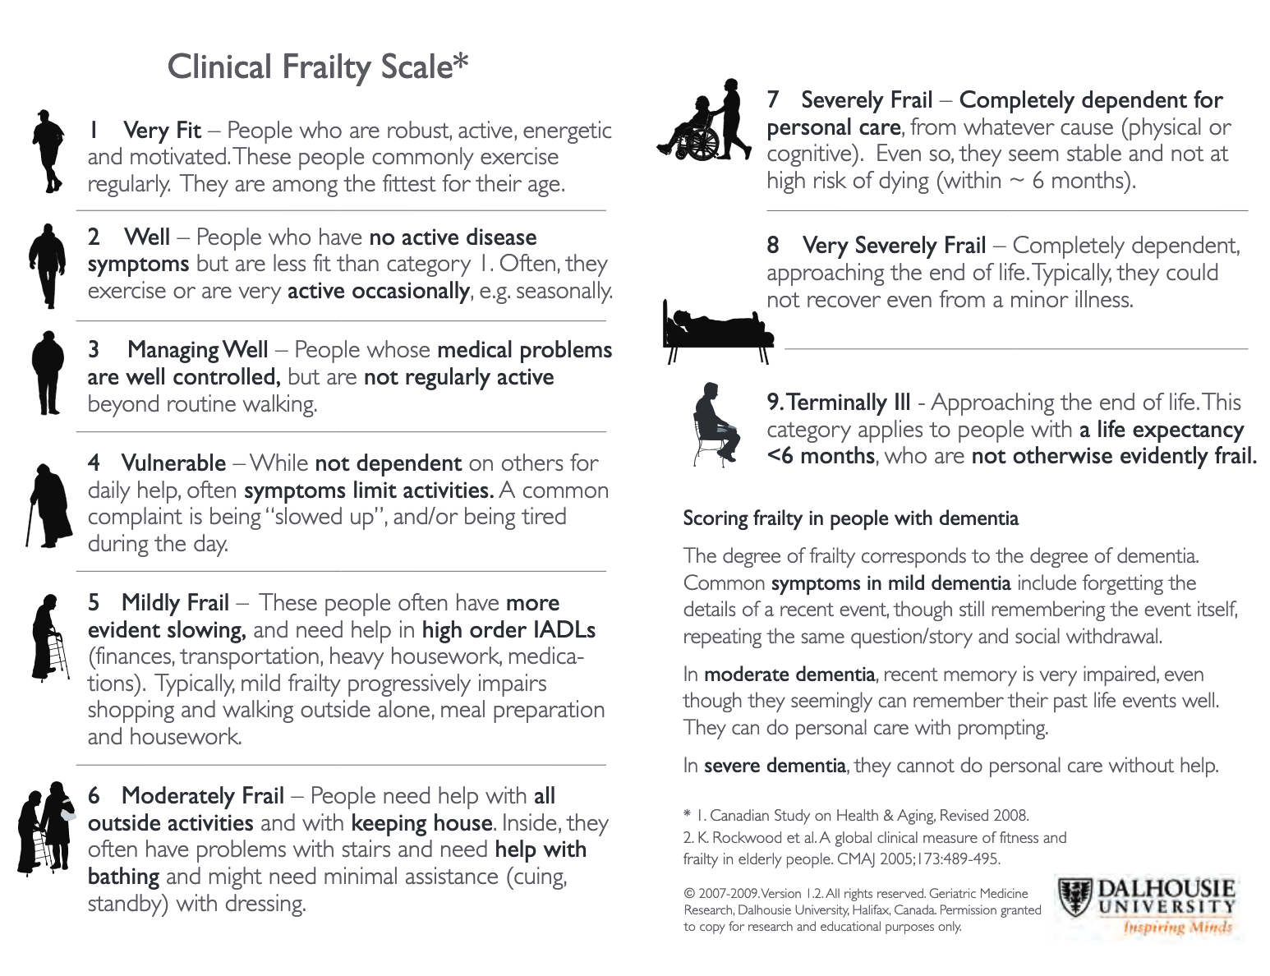

# Appendix 3 Top Tips

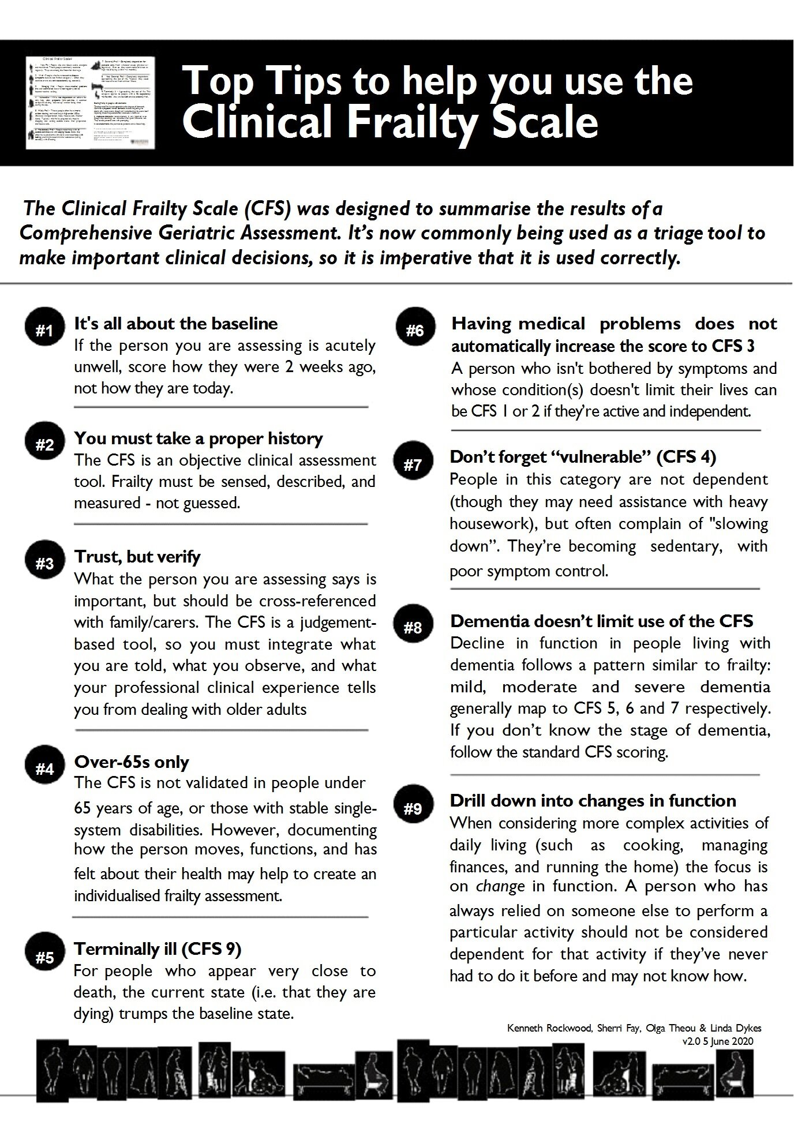

# Appendix 4 Clinical Frailty Scale (CFS): Classification Tree

