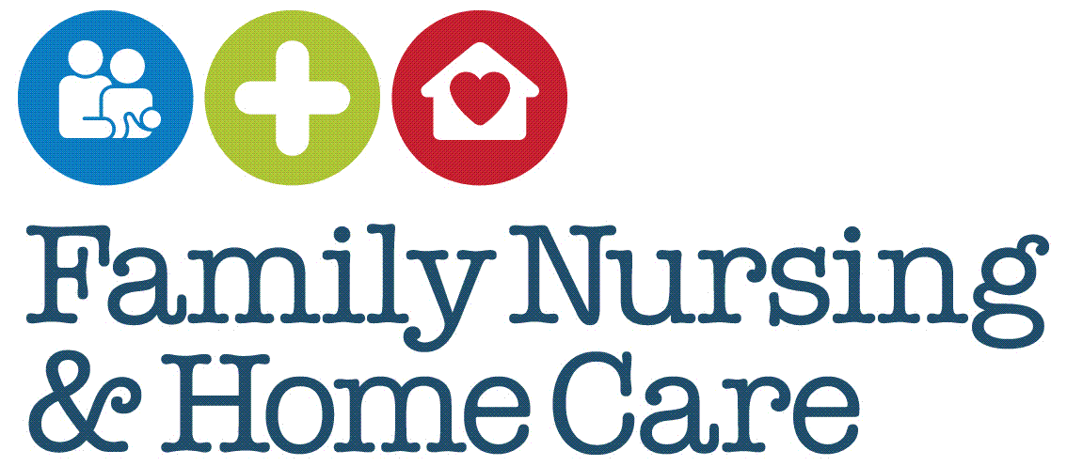

**Standard Operating Procedures**

**Sharps Injury and/or Blood/Body Fluid Exposure Procedure**

February 2025

**Document Profile**

|  |  |
| --- | --- |
| **Type** | Standard Operating Procedures |
| **Title** | Sharps Injury and/or Blood/Body Fluid Exposure Procedure |
| **Author(s)** | Rachel Foster – Quality & Performance Development Nurse |
| **Category** | Clinical |
| **Version** | 4.0 |
| **Approval Route** | Organisational Governance Approval Group (OGAG) |
| **Date approved** | 5th February 2025 |
| **Review date** | 3 years from approval |
| **Document Status** | This is a controlled document. Whilst it may be printed, the electronic version posted on the intranet is the controlled copy. Any printed copies of this document are not controlled. As a controlled document, it should not be saved onto local or network drives but should always be accessed from the intranet. |

**Version Control**

|  |  |  |
| --- | --- | --- |
| **Date** | **Version** | **Summary of changes made** |
| September 2021 | 3.0 | Previous procedure document transferred onto new SOP template  Content reviewed and updated where necessary, in consultation with Health and Community Services Community Infection Control Nurse. |
| February 2025 | 4.0 | Previous SOP transferred on to new document template.  Full review of SOP and updated where required. |

**Contents**

Introduction 4

SOP 1 Immediate Action 6

SOP 2 Further Management and Blood Tests 7

SOP 3 Follow up Care 9

References 10

# Introduction

Sharps injuries and exposure to blood or bodily fluids present a risk of transmitting infections, including hepatitis B (HBV), hepatitis C (HCV), and human immunodeficiency virus (HIV). These Standard Operating Procedures (SOPs) provide guidance on the required actions following a sharps injury or exposure incident, ensuring the safety of staff and others involved.

This procedure document applies to all staff who may come into contact with medical sharps or blood and bodily fluids, including situations involving human or animal bites. It also outlines specific actions required by other staff members and considerations relevant to patients.

For the purposes of this SOP, ‘exposure’ is defined as:

* Percutaneous injuries, such as those caused by used needles, sharp objects, or bites that break the skin.
* Mucocutaneous exposure, including splashes into the eyes, mouth, or onto broken skin (e.g., cuts or eczema).
* Human bites that result in broken skin.

**Risk of Transmission**

Exposure to contaminated sharps or bodily fluids carries the potential to transmit blood-borne viruses (BBVs). Factors influencing transmission risk include:

* Whether the source patient is infected.
* The viral load in the source patient’s blood.
* The volume of blood or bodily fluid involved.
* The type of sharp object used.
* The time elapsed since the injury.
* The nature and depth of the injury.
* The immune status of the injured person (HSE, 2022; PHE, 2019; Riddell et al., 2015).

Exposure of unbroken skin to blood or bodily fluids has not been associated with BBV transmission. Injuries involving unused needles or sharps also do not pose a risk of BBV transmission but should still be cleaned thoroughly, with the wound covered by a waterproof dressing to reduce infection risk.

**Low-Risk Exposures**

Certain body fluids, such as urine, vomit, faeces, sputum, and saliva, are typically considered low risk unless visibly contaminated with blood. Appropriate cleaning and monitoring are still recommended in such cases to minimise other infection risks (RCN, 2023; HSE, 2013).

**Source Patient**

The Source Patient refers to the individual whose blood or bodily fluids were involved in the exposure incident. Identifying and assessing the source patient is an essential step in evaluating the risk of infection and determining the required follow-up actions.

**Key Considerations**

To minimise the risk of sharps injuries and exposure:

* Conduct thorough risk assessments.
* Provide staff education and training on the safe use and disposal of sharps.
* Implement the use of safety-engineered sharps devices wherever possible.
* Follow proper procedures for handling and disposing of contaminated items.

(RCN, 2023; WHO, 2020; PHE, 2019; UKHSA, 2021).

# SOP 1 Immediate Action

|  |
| --- |
| ***Purpose*** |

To outline the immediate action to take following an exposure injury

|  |
| --- |
| ***Scope*** |

This SOP applies to any employee who sustains an exposure injury

|  |
| --- |
| ***Core Requirements/Procedure*** |

In the event of an exposure injury, the affected staff member must take the following steps promptly:

**Clean the Affected Area**

* Wash the affected area thoroughly with copious amounts of running water.
* If the exposure involves the eyes and contact lenses are worn, irrigate the eyes both before and after removing the lenses.

**Cover the Wound**

If the injury is still bleeding, apply a plaster or waterproof dressing to the affected area.

**Record the Incident**

Document the incident in the patient or client’s records.

**Inform the Line Manager**

Notify the Line Manager of the incident immediately. If the incident occurs outside normal working hours, inform the On-Call Manager.

**Seek Medical Attention**

Attend the Emergency Department (ED) at the hospital as soon as possible, ideally within one hour of exposure, for appropriate assessment and treatment.

**Report the Incident**

Complete an incident report via the Assure system as soon as possible after the injury has occurred.

# SOP 2 Further Management and Blood Tests

|  |
| --- |
| ***Purpose*** |

To provide guidance on the steps to take following the immediate management of an exposure injury.

|  |
| --- |
| ***Scope*** |

 This SOP applies to all employees who sustain an exposure injury.

|  |
| --- |
| ***Core Requirements/Procedure*** |

**Assessment at the Emergency Department (ED)**

* A healthcare professional at the ED will assess the injury by asking the staff member questions about how and when the incident occurred, as well as identifying who used any equipment involved. This assessment will determine the level of infection risk.
* A blood sample will typically be taken from the injured staff member to test for hepatitis B, hepatitis C, and HIV.
* If required, the staff member may be recalled for subsequent blood tests. This follow-up process will be managed by the Health and Community Services (HCS) Infection Prevention and Control Team (IPAC).

**Source Patient Blood Testing**

* Based on the verbal risk assessment undertaken at the ED, the relevant hospital staff will determine if a blood sample is required from the source patient.
* The source patient must be approached to request a blood sample for testing, with their informed consent obtained in line with the FNHC [Consent to Treatment and Care Policy](https://www.fnhc.org.je/procedure-library/).
* If the source patient cannot be identified, refuses consent for testing, or lacks the capacity to consent to Post-Exposure Prophylaxis (PEP), a risk assessment must be conducted to determine the need for PEP. This assessment may be carried out by the HCS team, based on the available evidence.
* The source patient’s blood sample can be taken either by a Family Nursing & Home Care (FNHC) colleague or the source patient’s GP.
* Any costs incurred by the source patient, such as GP charges, will be covered by Family Nursing & Home Care.
* The staff member who sustained the injury must not take the blood sample from the source patient.
* The blood sample should be collected in a clotted sample tube and sent to virology for testing for hepatitis B, hepatitis C, and HIV.

**Documentation**

All actions taken must be recorded in the Assure incident reporting system by the injured staff member.

# SOP 3 Follow up Care

|  |
| --- |
| ***Purpose*** |

To outline the follow-up care considerations post exposure injury

|  |
| --- |
| ***Scope*** |

This SOP applies to any employee who sustains an exposure injury

|  |
| --- |
| ***Core Requirements/Procedure*** |

**Advice on Further Testing**

The Health & Community Services Infection Prevention and Control Team will advise the injured staff member if further blood testing is required, and the appropriate timing for these tests.

**Counselling and Emotional Support**

The emotional well-being of staff members who sustain sharps injuries or are exposed to blood or bodily fluids should be prioritised. Consideration should be given to whether counselling is needed to support the individual.

FNHC colleagues can avail of the Sustaining Resilience at Work Peer Support Programme (StRaW). Details on how to refer to the programme are available in the FNHC [Standard Operating Procedures for Sustaining Resilience at Work Peer Support Programme](https://www.fnhc.org.je/procedure-library/).

(StRaW)

The Infection Prevention and Control Team at Health and Care Jersey can also provide guidance or arrange counselling services if required.

# References

|  |
| --- |
| Hakala, S. (2024) Prevention and Management of Sharps Injuries. Clinical Skills Limited. Available (with FNHC login) via <https://fnhc.app.clinicalskills.net/organisation_user/organisations/226/content_view/sections/1/categories/1/procedures/506> Last accessed 13/01/2025  Health and Safety Executive (2013) Health and Safety (Sharps Instruments in Healthcare) Regulations 2013. Guidance for Employers and Employees. Available via: <http://dickyricky.com/Medicine/Papers/2015_08_01%20BMJ%20Management%20of%20sharps%20injuries.pdf> Last accessed 13/01/2025  Health and Safety Executive (HSE). (2022) How to deal with an exposure incident. London, UK: HSE. Available via: <https://www.hse.gov.uk/biosafety/blood-borne-viruses/how-deal-exposure-incident.htm> Last accessed 13/01/2025  Public Health England (2019) Guidance on management of potential exposure to blood-borne viruses in emergency workers – For occupational health services providers and frontline staff. Available via <https://assets.publishing.service.gov.uk/government/uploads/system/uploads/attachment_data/file/835888/Guidance_on_management_of_potential_exposure_to_blood__2_.pdf> Last accessed 13/01/2025  Riddell A, Kennedy I, Tong C Y W. (2015) Management of sharps injuries in the healthcare setting BMJ 2015; 351 :h3733 doi:10.1136/bmj.h3733 Available via: [https://www.bmj.com/content/351/bmj.h3733 Last accessed 13/01/2025](https://www.bmj.com/content/351/bmj.h3733%20Last%20accessed%2013/01/2025)  Royal College of Nursing (2023) Sharps Safety: RCN Guidance for the Prevention and Management of sharps injuries in health and social care settings. Available via: <https://www.rcn.org.uk/Professional-Development/publications/rcn-sharps-safety-uk-pub-010-596> Last accessed 13/01/2025.  UK Health Security Agency (2021) Eye of the Needle: United Kingdom Surveillance of Significant Occupational Exposures to Bloodborne Viruses in Healthcare Workers. Available via: <https://www.gov.uk/government/publications/bloodborne-viruses-eye-of-the-needle> Last accessed 13/01/2025  World Health Organization (2020) WHO-ILO Global Framework for National Occupational Health Programmes for Health Workers. Available via: <https://www.who.int/news/item/10-06-2020-who-ilo-global-framework-for-national-occupational-health-programmes-for-health-workers> Last accessed 13/01/2025 |